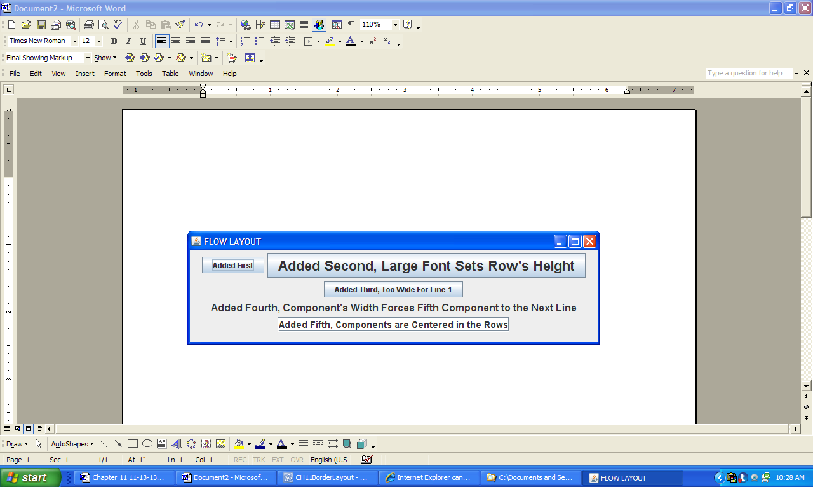

**Figure 11.35 A GUI built using the FlowLayout manager.**